

**Policy for**

**Safeguarding Children**

**&**

**Child Protection**

**EYFS, Primary, Secondary and Post 16**

**Last reviewed: September 2020 by Fiona Roberts (DSL)**

**Date of next review: September 2021**

CONTENTS

About This Policy ………………………………………………………………......................... 3

Commitment Statement …………….…………………………………………..….................... 3

Blossom House Culture of Vigilance …..……………………………………………… ……… 3

Children with Special Educational Needs and Disabilities…………………………………… 4

Safeguarding and Child Protection Training Requirements….…………………………… 4

Management of Safeguarding and the Role of the DSL……………………………………... 5

Multi-Agency Working and the Three Safeguarding Partners.………………………………. 5

Child Protection and the Four Categories of Abuse……………………………………….…. 6

Safeguarding Issues..…………….……………………………………………..………………. 7

Contextual Safeguarding……………………………………………………………………….. 9

Teaching Pupils about Safeguarding through the Holistic Curriculum……………………… 9

Keeping Pupils Safe Online…………………………………………………………................. 9

Reporting Child Protection and Safeguarding Concerns…………………………………….. 10

What Happens after a Concern is Reported?.................................................................... 10

Pupil Voice………………………………………………………………………………………… 11

Information Sharing and ‘Special Category Personal Data’………………………….……… 12

Record Keeping………………………………………………………………………….……... 12

Supporting Children Known to Social Care…………………………………………………… 12

Early Help………………………………………………………………………………….……... 13

Allegations of Peer on Peer Abuse (Including Sexual Violence and Harassment)……...... 14

Allegations made against Staff, Supply Staff, Students or Volunteers……………..………. 14

EYFS Reporting………………………………………………………………………………….. 15

Referring to DBS and TRA…………………………………………………………….………… 16

Reducing Risks……………………………………………………………………………......…. 16

Whistleblowing……………………………………………………………………………………. 16

APPENDICIES

Appendix 1: Signs and Symptoms of Abuse………………………………………….……….. 17

Appendix 2: Reporting Concerns…………………………………………………………........ 19

Appendix 3: Contact Details……………………………………………………………............. 20

**About this Policy**

This policy is updated at least annually, and reflects the latest government guidance and legislation. Blossom House School follows procedures in line with Merton’s Safeguarding Children’s Partnership (MSCP). This policy has been written with reference to the following:

* [Keeping children safe in education September 2020](https://assets.publishing.service.gov.uk/government/uploads/system/uploads/attachment_data/file/912592/Keeping_children_safe_in_education_Sep_2020.pdf)
* [Working together to safeguard children July 2018](https://assets.publishing.service.gov.uk/government/uploads/system/uploads/attachment_data/file/729914/Working_Together_to_Safeguard_Children-2018.pdf)
* [What to do if you’re worried a child is being abused March 2015](https://www.gov.uk/government/uploads/system/uploads/attachment_data/file/419604/What_to_do_if_you_re_worried_a_child_is_being_abused.pdf)
* [Sexual violence and sexual harassment between children in schools and colleges 2018](https://www.gov.uk/government/publications/sexual-violence-and-sexual-harassment-between-children-in-schools-and-colleges)
* [The Prevent duty June 2015](https://www.gov.uk/government/uploads/system/uploads/attachment_data/file/439598/prevent-duty-departmental-advice-v6.pdf)

In order to cover all safeguarding requirements, the following policies should also be read:

* Staff Code of Conduct
* Whistleblowing Policy
* Behaviour Policy
* Attendance Policy (with CME procedures)
* Safeguarding Procedures for Blossom House Foundation Stage

**Commitment Statement**

*“Blossom House School is committed to safeguarding and promoting the welfare of children and young people and expects all staff, students and volunteers to share this commitment.”*

Safeguarding and promoting the welfare of children is defined as:

* Protecting children from maltreatment
* Preventing impairment of children’s mental and physical health or development
* Ensuring children are growing up in circumstances consistent with the provision of safe and effective care
* Taking action to enable all children to have the best outcomes

‘Children’ includes everyone under the age of 18(*for 18+ please refer to our Safeguarding Vulnerable Adults Policy)*

**Blossom House Culture of Vigilance**

Safeguarding and promoting the welfare of children is ***everyone’s*** responsibility. Blossom House School actively promotes a culture of vigilance, and everyone who comes into contact with children has a role to play in identifying concerns, providing help, and taking action to prevent concerns from escalating. Our approach to safeguarding is child-centred where all staff consider, at all times, the best interests of the child. As part of their annual suitability form, all staff have signed to say they have read[*part 1 of Keeping children safe in education September 2020*](https://assets.publishing.service.gov.uk/government/uploads/system/uploads/attachment_data/file/912593/Keeping_children_safe_in_education_part_1_Sep_2020.pdf) guidance for schools and colleges.

**Children with Special Educational Needs and Disabilities**

As a special school, we recognise the fact that children with special educational needs and disabilities can face additional safeguarding challenges. These can include:

* Assumptions that indicators of possible abuse such as behaviour, mood and injury relate to the child’s disability without further exploration
* Being more prone to peer group isolation than other children
* The potential for children with SEN and disabilities being disproportionally impacted by behaviours such as bullying, without outwardly showing any signs
* Communication barriers and difficulties in overcoming these barriers

To address these additional challenges, Blossom House School provides Early Help as soon as early concerns are identified. We are also aware of the Local Authority requirement to provide services for Children in Need for the purposes of safeguarding and promoting their welfare, under section 17 of the Children Act 1989.

**Safeguarding and Child Protection Training Requirements**

**All new staff (including peripatetic staff, students and volunteers) will be required to:**

* Read our declaration policies before starting at Blossom House School. These include:
* Safeguarding Children and Child Protection Policy
* Staff Code of Conduct
* Whistleblowing Policy
* Behaviour Policy
* Attendance Policy (with CME Procedures)
* Read Part 1 of Keeping children safe in education September 2020
* Sign a confidentiality agreement
* Complete an induction session with the DSL within their first week of employment

**All existing staff will be required to:**

* Read Part 1 of Keeping children safe in education September 2020
* Complete annual refresher training
* Keep up to date with guidance, policies and procedures- delivered in staff meetings, by email etc.

**The Principal, DSL, Deputy DSL and Safeguarding Advisors will be required to:**

* Complete Advanced Safeguarding Training every 2 years
* Keep up to date with the latest guidance, policies and procedures
* At least one staff member on an interview panel will be trained in Safer Recruitment

**Management of Safeguarding and the Role of the DSL**

Blossom House School has Designated Safeguarding Lead (DSL), who is also a member of the senior management team. The DSL has **lead responsibility** for safeguarding and child protection, and provides support to staff members to carry out their safeguarding duties. Blossom House School also has two Deputy DSLs, who take on the DSL role in the DSL’s absence.

|  |  |
| --- | --- |
|  | **DSL: Fiona Roberts**   * Manages all safeguarding concerns for children and vulnerable adults * Shares relevant information about children’s welfare, safeguarding and child protection issues with school staff and senior management * Provides advice for **all staff** to carry out their safeguarding duties * Refers cases of suspected abuse to children’s social care * Refers cases of radicalisation to the Channel programme * Refers cases where a crime may have been committed to the Police * Refers cases where a person is dismissed or left due to risk/harm to a child to the Disclosure and Barring Service (DBS) * Responsible for the data protection of all CP records   **Deputy DSL: Viviana Patterson**   * Takes on DSL role in DSL’s absence |
|  | **Principal and Deputy DSL: Joey Burgess**   * Manages allegations against staff * Liaises with the LADO if an allegation is made against a member of staff * Meets regularly with the DSL to discuss cases, especially ongoing enquiries under section 17 or section 47 of the Children Act 1989, police investigations and referrals to LADO (where appropriate) * Takes on DSL role in DSL’s absence |
| cid:23AAAE71-FB71-4D83-A13E-DC01F1CAA6A1@Home | **Safeguarding Lead Member on the Advisory Body: Jill Bainton**   * Ensures school’s safeguarding protocols are robust * Carries out annual safeguarding audit to check compliance * May be contacted for independent safeguarding advice * May be contacted for any minor concerns around the Proprietor or Senior Management Team. |

**Multi-Agency Working and the Three Safeguarding Partners**

The DSL (and deputies) understand the importance of multi-agency working, in line with the statutory guidance set out in [Working Together to Safeguard Children 2018](https://assets.publishing.service.gov.uk/government/uploads/system/uploads/attachment_data/file/729914/Working_Together_to_Safeguard_Children-2018.pdf). Where safeguarding incidents occur, Blossom House will liaise with the three safeguarding partners (children’s services, police chief constables, and clinical commissioning groups), and other agencies, to promote the welfare of children and protect them from harm. Blossom House School works with Merton Safeguarding Children’s Partnership (MSCP) to follow local arrangements. The DSL is also aware of the NPCC guidance: [when to call the police.](https://www.npcc.police.uk/documents/Children%20and%20Young%20people/When%20to%20call%20the%20police%20guidance%20for%20schools%20and%20colleges.pdf)

**Child Protection and the Four Categories of Abuse**

Child protection is the process of protecting individual children who are suffering, or are likely to suffer, significant harm as a result of abuse or neglect.

**Abuse** isa form of maltreatment of a child. Somebody may abuse or neglect a child by inflicting harm or by failing to act to prevent harm. Children may be abused in a family or in an institutional or community setting by those known to them or, more rarely, by others. Abuse can take place wholly online, or technology may be used to facilitate offline abuse. Children may be abused by an adult or adults or by another child or children.

There are four categories of child abuse. These are:

**Physical Abuse** is a form of abuse which may involve hitting, shaking, throwing, poisoning, burning or scalding, drowning, suffocating or otherwise causing physical harm to a child. Physical harm may also be caused when a parent or carer fabricates the symptoms of, or deliberately induces, illness in a child.

**Emotional Abuse** is the persistent emotional maltreatment of a child such as to cause severe and adverse effects on the child’s emotional development. It may involve conveying to a child that they are worthless or unloved, inadequate, or valued only insofar as they meet the needs of another person. It may include not giving the child opportunities to express their views, deliberately silencing them or ‘making fun’ of what they say or how they communicate. It may feature age or developmentally inappropriate expectations being imposed on children. These may include interactions that are beyond a child’s developmental capability as well as overprotection and limitation of exploration and learning, or preventing the child from participating in normal social interaction. It may involve seeing or hearing the ill-treatment of another. It may involve serious bullying (including cyberbullying), causing children frequently to feel frightened or in danger, or the exploitation or corruption of children. Some level of emotional abuse is involved in all types of maltreatment of a child, although it may occur alone.

**Sexual Abuse** involves forcing or enticing a child or young person to take part in sexual activities, not necessarily involving violence, whether or not the child is aware of what is happening. The activities may involve physical contact, including assault by penetration (rape or oral sex) or non-penetrative acts such as masturbation, kissing, rubbing and touching outside of clothing. They may also include non-contact activities, such as involving children in looking at, or in the production of, sexual images, watching sexual activities, encouraging children to behave in sexually inappropriate ways, or grooming a child in preparation for abuse. Sexual abuse can take place online, and technology can be used to facilitate offline abuse. Sexual abuse is not solely perpetrated by adult males. Women can also commit acts of sexual abuse, as can other children. The sexual abuse of children by other children is a specific safeguarding issue in education.

**Neglect** is the persistent failure to meet a child’s basic physical and/or psychological needs, likely to result in the serious impairment of the child’s health or development. Neglect may occur during pregnancy, for example, as a result of maternal substance abuse. Once a child is born, neglect may involve a parent or carer failing to: provide adequate food, clothing and shelter (including exclusion from home or abandonment); protect a child from physical and emotional harm or danger; ensure adequate supervision (including the use of inadequate care-givers); or ensure access to appropriate medical care or treatment. It may also include neglect of, or unresponsiveness to, a child’s basic emotional needs.

Abuse, neglect and safeguarding issues are rarely standalone events and in most cases, multiple issues will overlap with one another. Knowing what to look for is vital to the early identification of abuse and neglect. **Please refer to Appendix 1 for signs and symptoms of abuse**.

**Safeguarding Issues** *see Annex A of Keeping Children Safe in Education 2020*

There are many safeguarding issues that can put children at risk of harm. Behaviours linked to issues such as drug taking, alcohol abuse, deliberately missing education and sexting (also known as youth produced sexual imagery) put children in danger.

**Child Sexual Exploitation (CSE) and Child Criminal Exploitation (CCE)**

Both CSE and CCE are forms of abuse and both occur where an individual or group takes advantage of an imbalance in power to coerce, manipulate or deceive a child into sexual or criminal activity. Whilst age may be the most obvious, this power imbalance can also be due to a range of other factors including gender, sexual identity, cognitive ability, physical strength, status, and access to economic or other resources. In some cases, the abuse will be in exchange for something the victim needs or wants and/or will be to the financial benefit or other advantage (such as increased status) of the perpetrator or facilitator. The abuse can be perpetrated by individuals or groups, males or females, and children or adults. The abuse can be a one-off occurrence or a series of incidents over time, and range from opportunistic to complex organised abuse. It can involve force and/or enticement-based methods of compliance and may, or may not, be accompanied by violence or threats of violence. Victims can be exploited even when activity appears consensual and it should be noted exploitation as well as being physical can be facilitated and/or take place online. If CSE or CCE is suspected, staff must report to the DSL immediately.

**Peer on peer abuse** (*refer to page 14 of this policy, for how to respond to such incidents)*

Where children abuse other children, this is referred to as peer on peer abuse. This is most likely to include, but may not be limited to:

• bullying (including cyberbullying);

• physical abuse such as hitting, kicking, shaking, biting, hair pulling, or causing physical harm;

• sexual violence, such as rape, assault by penetration and sexual assault;

• sexual harassment, such as sexual comments, remarks, jokes and online sexual harassment, which may be stand-alone or part of a broader pattern of abuse;

• upskirting, which typically involves taking a picture under a person’s clothing without them knowing, with the intention of viewing their genitals or buttocks to obtain sexual gratification, or cause the victim humiliation, distress or alarm;

• sexting (also known as youth produced sexual imagery); and

• initiation/hazing type violence and rituals.

**Serious violence**

Indicators which may signal that children are at risk from, or are involved with serious violent crime, may include: increased absence from school, a change in friendships or relationships with older individuals or groups, a significant decline in performance, signs of self-harm or a significant change in wellbeing, or signs of assault or unexplained injuries. Unexplained gifts or new possessions could also indicate that children have been approached by, or are involved with, individuals associated with criminal networks or gangs. Any concerns around serious violence should be discussed with the DSL. Advice for schools and colleges is provided in the Home Office’s [Preventing youth violence and gang involvement](https://assets.publishing.service.gov.uk/government/uploads/system/uploads/attachment_data/file/418131/Preventing_youth_violence_and_gang_involvement_v3_March2015.pdf) and its [Criminal exploitation of children and vulnerable adults: county lines guidance](https://assets.publishing.service.gov.uk/government/uploads/system/uploads/attachment_data/file/741194/HOCountyLinesGuidanceSept2018.pdf).

**Female Genital Mutilation (FGM)**

Whilst all staff should speak to the DSL with regard to any concerns about female genital mutilation (FGM), there is a specific legal duty on teachers. If a teacher, in the course of their work in the profession discovers that an act of FGM appears to have been carried out on a girl under the age of 18, the teacher must also report this to the police.

**Mental Health**

Blossom House School recognises that mental health problems can, in some cases, be an indicator that a child has suffered or is at risk of suffering abuse, neglect or exploitation. Where children have suffered traumatic adverse childhood experiences, this can have a lasting impact throughout childhood, adolescence and into adulthood, and can impact on their mental health, behaviour and education. If staff identify a child whose behaviour suggests that they may be experiencing a mental health problem, or may be at risk of developing one, they should report to child’s Specialist Advisor. If staff have a mental health concern about a child that is also a safeguarding concern, they should report to the DSL immediately. Blossom House School has also commissioned a Clinical Specialist and Family Therapist through the Merton TaMHS (Targeted Mental Health in Schools). Our TaMHS clinicians are available weekly to offer additional support for pupils who may be facing mental health difficulties.

For more information on Safeguarding Issues, including: Child Sexual Exploitation, Child Criminal Exploitation, County Lines, Domestic Abuse, Honour-Based Abuse, Preventing Radicalisation and Upskirting, please see [*Annex A of Keeping Children Safe in Education*](https://assets.publishing.service.gov.uk/government/uploads/system/uploads/attachment_data/file/828312/Keeping_children_safe_in_education.pdf)*.*

**Contextual Safeguarding**

All staff are aware that safeguarding incidents and/or behaviours can be associated with factors outside the school and/or can occur between children outside of the school environment. The DSL, alongside all staff, will consider whether children are at risk of abuse or exploitation in situations outside their families. This can include (but is not limited to) sexual exploitation, criminal exploitation and serious youth violence.

**Teaching Pupils about Safeguarding through the Holistic Curriculum**

Blossom House School is a secular, non-political institution. The school’s Holistic Curriculum promotes the spiritual, moral, social and cultural (SMSC) development of pupils and within this, Fundamental British Values (FBV). Pupils are taught about diverse national, religious and ethnic identities and beliefs, and the need for mutual respect and understanding to prevent extremist views. PSHE, RSE and Life Skills lessons enable children to develop their understanding, awareness, and resilience to potential safeguarding issues, including online safety (see below) and sexting.

**Keeping Pupils Safe Online** *(please refer to our Digital Devices Policy)*

Blossom House recognises the importance of keeping children safe online. IT filtering systems are in place which prevents access to inappropriate material, including pornographic and extremist sites. We are mindful of “over blocking” and ensure that pupils continue to have reasonable access to support their learning around safeguarding topics.

All staff, pupils and parents have an awareness of e-safety practices, and annual training sessions are delivered through the Childnet online safety charity [www.childnet.com](http://www.childnet.com). These sessions raise awareness of the three main areas of risk:

• **Content:** being exposed to illegal, inappropriate or harmful material;

• **Contact:** being subjected to harmful online interaction with other users; and

• **Conduct:** personal online behaviour that increases the likelihood of, or causes, harm.

Blossom House School recognises the importance of teaching pupils about online safety, and helping them to be clear about what is expected of them online as offline. This includes when they are online at home.

For more information on keeping children safe online please see [*Annex C of Keeping Children Safe in Education*](https://assets.publishing.service.gov.uk/government/uploads/system/uploads/attachment_data/file/828312/Keeping_children_safe_in_education.pdf)*.*

**Reporting Safeguarding and Child Protection Concerns**

Staff members who are in contact with children all day, are in a position to detect possible abuse. Our Culture of Vigilance ensures that staff maintain an attitude of **‘it could happen here’** and that they do not assume a colleague will take action or report a concern instead. When concerned about the welfare of a child, staff members should always act in the **best interests of the child**. If staff members are unsure they should **always** speak to the DSL.

If you are concerned that a child is being (or has been) abused; if you notice any unusual injuries or marks; or if you are concerned about any of the specific safeguarding issues, you should:

* **Ask the child how it happened**. Listen carefully to what the child is saying, treat it seriously, and value what they say. If you can, write brief notes.
* **Do not promise the pupil that it will be kept a secret.** You have a responsibility to make sure they are safe. Give reassurance that only those who need to know will be told.
* **Do not ask leading questions.** These might give your own idea of what might have happened. Ask open questions such as *“What happened?”; “Is there anything else?”*
* Record what has been observed & said as soon as possible via the SchoolPod secure reporting system (see **Appendix 2** on how to report concerns). The notes should not reflect the personal opinion of the note taker as they could become part of a statutory assessment by children’s social care and/or part of a criminal investigation.
* **If the child is considered to be at risk of harm, notify the DSL immediately. An urgent referral may need to be made to children’s social care and/or the police.**
* The DSL or Deputy DSL will always be available to discuss safeguarding concerns. If the DSL or Deputy DSL are not available, a member of the Senior Management Team should be contacted. In these circumstances, any action taken should be shared with the DSL (or deputy) as soon as is practically possible.
* In circumstances where a child requires urgent medical attention, the referral process should not delay the administration of First Aid or emergency medical assistance.

**What Happens after a Concern is Reported?**

Following notification of a safeguarding concern, the following options will include:

* Managing support for the child internally, drawing on the professional network and pastoral support available within Blossom House;
* An Early Help assessment;
* A referral for statutory services, for example as the child might be in need, is in need or suffering or likely to suffer harm.

**All staff, including the DSL must be prepared to challenge inaction if felt necessary.**

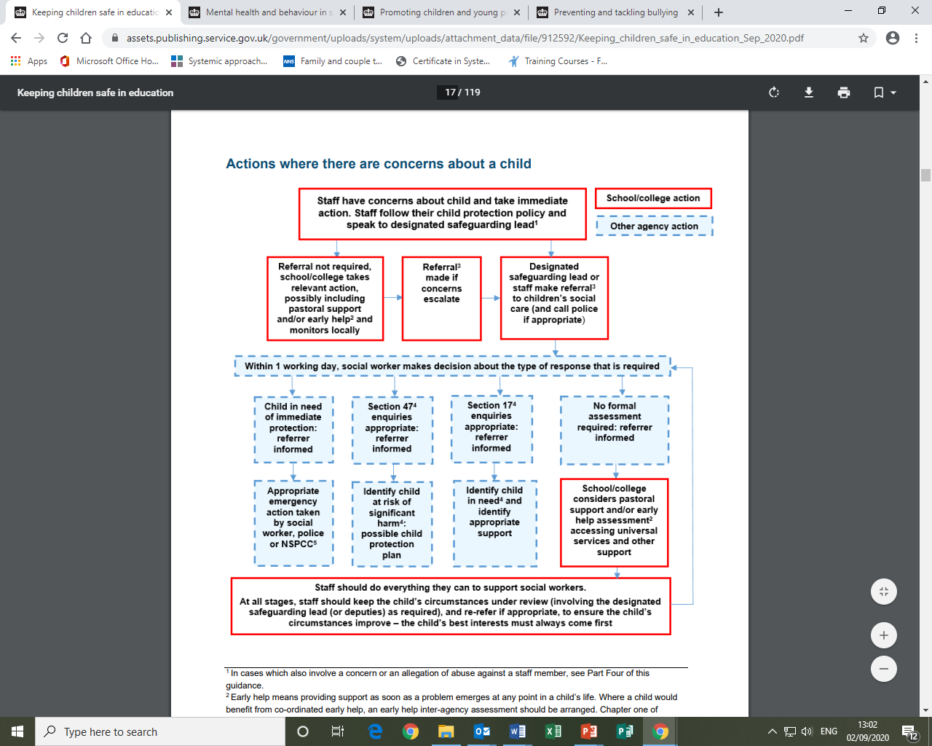The following diagram shows the referral process, including statutory assessments under the Children Act (1989):

Where a child is suffering, or is likely to suffer from harm, a referral to children’s social care (and if appropriate the police) must be made immediately. In the first instance, the DSL will contact Merton’s Multi-Agency Safeguarding Hub (MASH) or Local Authority equivalent (which can be found using this [online tool](https://www.gov.uk/report-child-abuse-to-local-council)). Parents’ agreement will be sought first, unless seeking agreement is likely to place the child at further risk, through delay or the parent's actions or reactions.

**Pupil Voice**

Blossom House recognises the importance of pupil voice. Where there is a safeguarding concern, we try our best to ensure the child’s wishes and feelings are taken into account when determining what action to take and what services to provide. Additional communication, therapeutic and pastoral support is in place for children to express their views and give feedback. In order to fulfil our safeguarding duties, we will always act in the best interests of the child.

**Information Sharing and ‘Special Category Personal Data’** *(see information sharing policy)*

Information sharing between practitioners and local agencies, is vital in identifying and tackling all forms of abuse and neglect. We understand the importance of sharing information as early as possible, when problems are first emerging, or where a child is already known to local authority children’s social care. We decide whether to share personal information on a case-by-case basis, applying the **Seven Golden Rules** for information sharing.

Any confidential, sensitive and personal information relating to safeguarding or child protection is treated as **special category personal data**. Consent should be sought from pupils and parents when sharing information, unless it is not possible to gain consent, or if to gain consent would put a child at risk of harm. The Data Protection Act 2018 contains *‘safeguarding of children and individuals at risk’* as a processing condition. This allows the sharing of information if it is to keep a child or individual safe from neglect or physical, emotional or mental harm, or if it is protecting their physical, mental, or emotional well-being.

***Duties to safeguard and protect children from risk of harm override those outlined in the GDPR or Data Protection Act 2018.***

Further information can be found in the [Data protection: toolkit for schools](https://assets.publishing.service.gov.uk/government/uploads/system/uploads/attachment_data/file/747620/Data_Protection_Toolkit_for_Schools_OpenBeta.pdf)

**Record Keeping**

All concerns, discussions and decisions made, are recorded in writing (usually electronically). If in doubt about recording requirements, staff should discuss with the DSL.

Information is stored on a restricted area of our SchoolPod system, or in the child’s Child Protection file on a restricted drive (if electronic) or in a locked cabinet (if a paper copy).

Where children leave Blossom House, the DSL will ensure their Child Protection file is transferred to the new school or college as soon as possible, ensuring secure transit, and obtaining confirmation of receipt. The DSL may share any information with the new school or college in advance of a child leaving (where necessary). When Blossom House receives a Child Protection file, this is marked as confidential, and for the attention of the DSL.

**Supporting Children Known to Children’s Social Care**

Where children are subject to a Child Protection or a Child in Need Plan, the school is responsible for liaising with Children’s Social Care and other relevant agencies, to ensure the welfare of these children are monitored. The DSL and key staff working with these children may be asked to contribute to the plan, or to be part of statutory meetings and conferences. Where children need a social worker, this will inform decisions about safeguarding e.g. responding to non-attendance, or providing additional pastoral support within the school.

Where children are Looked After, or previously Looked After, the DSL will ensure that appropriate staff have all the relevant information they need in relation to the child’s legal status, care arrangements, and contact arrangements with their birth parents. The DSL will have details of the social worker and the name of the virtual head in the authority that looks after the child.

Our Senior Manager **Vikki Langford** is the Designated Teacher responsible for promoting the educational achievement of children who have left care through adoption, special guardianship or child arrangement orders. All Looked After children must have a Personal Education Plan (PEP), which is developed by the Local Authority and reviewed in collaboration with the school.

**Early Help**

All staff working at Blossom House are able to identify children who may benefit from Early Help. Early Help means **providing support as soon as a problem emerges in a child’s life.**

Any child may benefit from Early Help, but we understand that children experiencing one or more of the following may be in particular need of Early Help support:

* Is disabled and has specific additional needs
* Has special educational needs
* Is a young carer
* Is showing signs of being drawn in to anti-social or criminal behaviour, including gang involvement and association with organised crime groups
* Is frequently missing/goes missing from care or from home
* Is at risk of modern slavery, trafficking or exploitation
* Is at risk of being radicalised or exploited
* Is in a family circumstance presenting challenges for the child, such as drug and alcohol misuse, adult mental health issues and domestic abuse
* Is misusing drugs or alcohol themselves
* Has returned home to their family from care
* Is a privately fostered child

Staff who identify a child as needing Early Help, should initially discuss their concerns with the child’s Specialist Advisor. Where there are safety concerns, where low level concerns persist, or where cases are more complex, the Specialist Adviser will discuss with the DSL. The DSL may then carry out an Inter-agency assessment through a CAF (or equivalent), and/or discuss with local children’s social care services. Either the DSL, Specialist Advisor, or an external agency will act as Lead Professional, coordinating Team Around the Child (TAC) meetings. All staff working with that child may be required to contribute to the assessment and review processes.

Early Help support is kept under constant review. **If the child’s situation does not seem to be improving, or if concerns escalate, a referral to children’s social care may be considered.**

**Allegations of Peer on Peer Abuse (Including Sexual Violence and Harassment)**

(please see [Sexual violence and sexual harassment between children in schools and colleges](https://assets.publishing.service.gov.uk/government/uploads/system/uploads/attachment_data/file/719902/Sexual_violence_and_sexual_harassment_between_children_in_schools_and_colleges.pdf) and [*UKCCIS Guidance: Sexting in schools and colleges, responding to incidents, and safeguarding young people 2016*](https://www.gov.uk/government/uploads/system/uploads/attachment_data/file/551575/6.2439_KG_NCA_Sexting_in_Schools_WEB__1_.PDF)*)*

It is important for staff to be aware that safeguarding issues can manifest themselves via peer on peer abuse. **Peer on peer abuse is abuse, and should never be tolerated or passed off as “banter”, “just having a laugh” or “part of growing up”**.We recognise the gendered nature of peer on peer abuse; whilst it is more likely that girls will be victims and boys perpetrators, all peer on peer abuse is unacceptable and will be taken seriously.

Where peer on peer abuse - including child on child sexual violence and sexual harassment- is suspected, or where an allegation has been made, **the DSL should be informed immediately**. If the allegation indicates a potential criminal offence has taken place, the Police will also be contacted. If the allegation is not accepted by Children’s Social Care or the Police, the school is responsible for managing the situation internally in accordance with the Behaviour Policy, Anti-Bullying Policy and the Social Networks Policy. Additional support may also be provided, including Early Help.

For more information on managing child on child sexual violence and sexual harassment, please see[*Part Five of Keeping Children Safe in Education*](https://assets.publishing.service.gov.uk/government/uploads/system/uploads/attachment_data/file/828312/Keeping_children_safe_in_education.pdf)

On occasion, some pupils will present a safeguarding risk to other pupils. The school is responsible for creating individualised risk assessments to ensure that the other pupils are safeguarded; and that these pupils are also kept safe from malicious allegations.

**Allegations Made Against Staff (including Supply Staff, Students or Volunteers)**

Allegations against a member of staff may come from another staff member, supply staff member, student or volunteer; from a pupil or a parent; or from an outside agency (the police, Local Authority etc.).

Allegations that indicate a person would pose a risk of harm if they continue to work in close contact with children include those who have:

* behaved in a way that has harmed a child, or may have harmed a child;
* possibly committed a criminal offence against or related to a child; or
* behaved towards a child or children in a way that indicates he or she may pose a risk of harm to children
* behaved or may have behaved in a way that indicates that they may not be suitable to work with children

*The DBS definition of ‘****harm’*** *includes: sexual harm, physical harm, financial harm, neglect, emotional harm, psychological harm or verbal harm.*

Any staff member who suspects that a colleague is acting in a way that may jeopardise a child’s welfare, or who receives an allegation of abuse from a pupil, parent or outside agency; must **inform the Principal immediately** *[as the Principal is also the sole proprietor of Blossom House Independent School, any allegation made about the Principal should be reported**directly to the Local Authority Designated Officer (LADO) 020 8545 3179;* [*lado@merton.gov.uk*](mailto:lado@merton.gov.uk)*].*

In the first instance, the Principal will immediately discuss the allegation with the LADO. If the person is deemed to be an immediate risk to children, the police should be called. The Principal should inform the accused person about the allegation as soon as possible and consider whether the circumstances warrant a person being suspended from contact with children, or whether alternative arrangements can be put in place until the allegation or concern is resolved. Appropriate support for this person will be provided during this period.

Where it is clear that an investigation by the police or children’s social care services is unnecessary, the Principal will consult with HR to determine the next course of action. This can range from taking no further action to dismissal.

Parents or carers of a child or children involved should be told about the allegation as soon as possible if they do not already know of it. However, where a strategy discussion is required, or police or children’s social care services need to be involved, these agencies should be consulted first and agreed what information can be disclosed to the parents or carers. It is extremely important that if an allegation is made, the school makes every effort to maintain confidentiality.

For more information on this process, please see[*Part four of Keeping Children Safe in Education*](https://assets.publishing.service.gov.uk/government/uploads/system/uploads/attachment_data/file/912592/Keeping_children_safe_in_education_Sep_2020.pdf)

***The school has a Safeguarding Lead Member on the Advisory Body, who may be contacted for any minor concerns around the Proprietor or Senior Management Team. Please contact via the Office.***

**EYFS Reporting** *(Please see Safeguarding Procedures for Blossom House Foundation Stage)*

Where an allegation has been made against a member of staff in the Early Years Foundation Stage, Blossom House School must also notify Ofsted of any allegations of serious harm or abuse by any person living, working, or looking after children at the premises (whether the allegations relate to harm or abuse committed on the premises or elsewhere). These notifications must be made as soon as is reasonably practicable, but at the latest within 14 days of the allegations being made. The Merton Early Years Team must also be informed on 02085453800 and/or an email to [providers@merton.gov.uk](mailto:providers@merton.gov.uk) (marked confidential and urgent).

**Referring to DBS *(Disclosure & Barring Service)* and TRA *(Teaching Regulation Agency)***

Blossom House School is aware of their obligation to refer any person (whether employed, contracted, a volunteer or student) to DBS if:

* They are dismissed because they have harmed someone;
* They are dismissed/removed from working in [regulated activity](https://www.gov.uk/government/publications/dbs-regulated-activity) because they might have harmed someone;
* They were going to be dismissed for either of these reasons, but they resigned first.

**Allegations of serious misconduct against a teacher may be referred to the TRA.**

**Reducing Risks**

The DSL is responsible for logging and monitoring safeguarding concerns. Commonly reported concerns are discussed with the Senior Management Team, and extra support is put in place to reduce any potential risks. A full safeguarding report is produced annually, which includes a detailed action plan. The findings of the report feed into the school development plan, with the overall aim to improve the safeguarding culture within the school. An annual Safeguarding Review is carried out by the Safeguarding Lead Member on the Advisory Body.

**Whistleblowing** *(please refer to the Whistleblowing Policy)*

All staff, students and volunteers should feel able to raise concerns about poor or unsafe practice and potential failures in the school safeguarding procedures; and these will be taken extrenmely seriously by the Senior Management Team. If for any reason, staff feel unable to raise within the school, they can call the NSPCC advice lineanonymously on **0800 028 0285** or email: [help@nspcc.org.uk](mailto:help@nspcc.org.uk). More information can also be found on the [NSPCC website](https://www.nspcc.org.uk/what-you-can-do/report-abuse/dedicated-helplines/whistleblowing-advice-line/).

**Signed:**

Joanna Burgess,

Principal

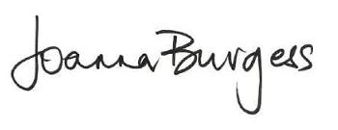

02.09.19

**Appendix 1**

Signs and Symptoms of Abuse

This is intended as a guide. Please remember that the presence of one or more factors does not necessarily give proof that child abuse has occurred. No list of abuse or neglect indicators can include all signs, and staff are advised to use their best judgement.

|  |  |
| --- | --- |
| **Indicators of Physical Abuse**   * Unexplained injuries, bruising or burns/scalds * Recurring injuries * Untreated injuries * Admission of punishment which appears excessive * Bald patches * Head/abdominal injuries * Soft tissue injury is ***very much a cause for concern.*** * Bruise marks in or around the mouth * Black eyes, especially if both eyes are black and there are no marks to forehead or nose * Grasp marks * Finger marks * Bruising of the ears * Linear bruising (particularly buttocks or back) * Bruising of differing age * injuries to genital areas* * Bite marks * Unexplained burns ,cigarette burns ,rope burns (*these are rarely accidental)* * General physical disability   **Behavioural indicators**   * Behavioural extremes (withdrawal, aggression, regression, depression) * Inappropriate or excessive fear of parent or caretaker * Antisocial behaviour such as substance abuse, running away, truancy, fear of going home. * Unbelievable or inconsistent explanation for injuries * Refusal to discuss injuries * Withdrawal from physical contact * Sudden poor performance in school * Self destructive tendencies * Aggression towards others * Over compliance * Resistance to PE (undressing) | **Indicators of Emotional Abuse**   * Physical, mental and emotional development lags * Low self-esteem * Sudden speech disorders * Fear of new situations * Inappropriate emotional responses to painful situations * Eating disorders, including obesity or anorexia * Nervous disorders (rashes, hives, facial tics, stomach aches) * Self-harm * Fear of parents being contacted * Running away * Compulsive stealing, scavenging * Difficulty in forming relationships * Soiling and wetting * Unresponsiveness in the child * Change in behavioural pattern * ‘Frozen’ look * Attention seeking * Sudden poor performance in school   **Behavioural indicators**   * Habit disorders (biting, rocking, head-banging) * Behaviours such as rocking, hair twisting etc * Cruel behaviour, seeming to get pleasure from hurting children, adults or animals * Age inappropriate behaviours (bedwetting, wetting, soiling) * Behavioural extremes, such as overly compliant-demanding; withdrawn-aggressive; listless-excitable. * Acceptance of excessive punishment * Over-reaction to mistakes * Continual self deprecation |
| **Indicators of Neglect**   * Constant hunger * Constant tiredness * Frequent lateness or non-attendance * No social relationships * Poor personal hygiene * Low self –esteem * Poor state of clothing * Unsuitable clothing; missing key articles of clothing(underwear, socks) * Repeated infections etc. * Untreated injury or illness * Lack of immunisations * Indications of prolonged Exposure to elements( excessive sunburn, insect bites, colds) * Unkempt appearance * Height and weight significantly below age level   **Behavioural indicators**   * Sudden poor performance in school * Compulsive stealing or scavenging * Destructive tendencies * Neurotic behaviour * Running away * Unusual school attendance | **Indicators of Sexual Abuse**   * Torn stained or bloody underclothes * Frequent unexplained sore throats, yeast or urinary infections * Somatic complaints, including pain and irritation of the genitals. * Sexually transmitted diseases * Bruises or bleeding from external genitalia, vaginal or anal region. * Self mutilation * Extremes of passivity or aggression * Withdrawal from physical contact * Fear of returning home * Emotionally distant * Self destructive tendencies * Confusing affectionate displays * Sexualised drawings and play * Soiling and wetting * Sexually precocious behaviour * Attention seeking   **Behavioural indicators**   * Disclosure of sexual abuse * Regressive behaviours (thumb sucking, bed wetting, fear of the dark) * Promiscuity or seductive behaviours * Sexually explicit behaviour * disturbed sleep patterns (recurrent nightmares) * unusual and age *inappropriate* interest in sexual matters * Avoidance of undressing or wearing extra layers of clothes * Sudden decline in school performance, truancy * Difficulty in walking or sitting. * Low self-esteem * Self-harm * Extremes of passivity or aggression * Drug/solvent abuse * Running away * Neurotic behaviour * Sexually inappropriate play for age of child * Withdrawal from physical contact * Fear of returning home * Emotionally distant * Self destructive tendencies * Confusing affectionate displays * Sexualised drawings and play * Soiling and wetting * Sexually precocious behaviour * Attention seeking * Sudden poor performance in school |

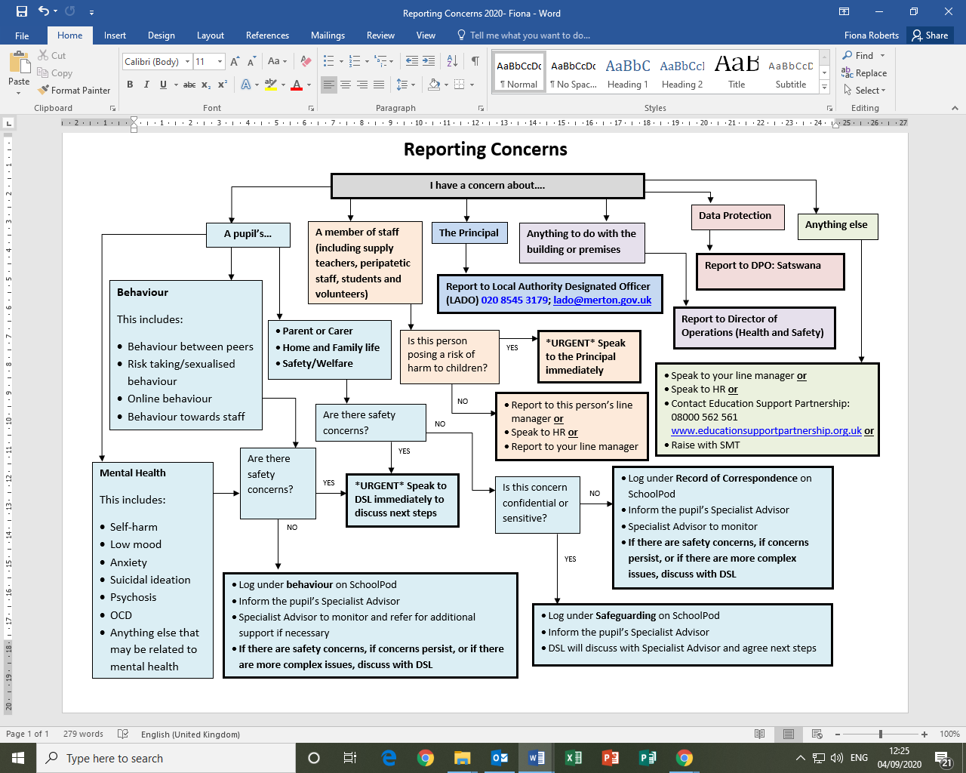**Appendix 2:**

**Appendix 3**

Contact List

**Children’s Social Care Finder**

<https://www.gov.uk/report-child-abuse-to-local-council>

**Merton’s MSCP** (For other LAs please use the finder above)

<https://www.mertonscp.org.uk/>

**Merton’s Multi Agency Safeguarding Hub (MASH):**

Monday-Friday 9:00am - 5:00pm: 020 8545 4226/4227. Out of Hours: 020 8770 5000

**Merton LADO (Local Authority Designated Officer):**

LADO: 020 8545 3179 [lado@merton.gov.uk](mailto:lado@merton.gov.uk)

**Police** Non-emergency: 101, Emergency: 999

**Catch 22 Merton Substance Abuse Service**

Advice and consultation:020 3701 8641 [msm@catch-22.org.uk](mailto:msm@catch-22.org.uk)

**Radicalisation and Extremism**

Telephone helpline 020 7340 7264 Email [counter.extremism@education.gsi.gov.uk](mailto:counter.extremism@education.gsi.gov.uk)

(Please note that the helpline is not intended for use in emergency situations, such as a child being at immediate risk of harm or a security incident, in which case the normal emergency procedures should be followed)

**Ofsted**

Piccadilly Gate, Store Street, Manchester, M1 2WD

Tel: 0300 123 1231 Email: [enquiries@ofsted.gov](mailto:enquiries@ofsted.gov) Web: [www.ofsted.gov.uk](http://www.ofsted.gov.uk)

**Disclosure and Barring Service (DBS)**

PO Box 181, Darlington, DL1 9FA Email: [customerservices@dbs.gsi.gov.uk](mailto:customerservices@dbs.gsi.gov.uk)

Telephone for referrals: 01325 953 795; Telephone for customer services: 0870 909 08

**NSPCC Child Protection Helpline:** 0808 800 5000

**Childline:** Tel: 0800 1111 www.childline.org.uk